INFORMATION SYSTEMS: ICE TASK 4
Group 7: Thamsanqa Nkosi Ncube - ST10482062 Kandyce Smit – ST10467645

Lecturer: Moses Olaifa
Module: INSY6211

Table of Contents
Use Case 1: Book Appointment 2
Use Case 2: Update Patient Medical Records 6
Use Case 3: Manage Prescription 9
Use Case 4: Generate Patient Summary Report 13

Use Case 1: Book Appointment
This use case covers how a patient schedules a consultation through the new digital system. Previously, appointment booking was done manually by receptionists writing entries into a paper register. With the digital system, real-time availability can be checked and confirmed instantly, cutting down on scheduling errors and waiting time.

Detailed Use Case Description
Use Case Name | Book Appointment
Scenario | Patient scheduling a consultation with a doctor at the hospital
Triggering Event | A patient requests an appointment through the digital hospital system
Brief Description | A patient logs into the system and selects an available doctor and time slot to book an appointment. The system confirms the booking and stores the record.
Actors | Patient, Receptionist
Related Use Cases | View Medical Records, Generate Patient Summary Report
Stakeholders | Patients, Receptionists, Doctors, Hospital Administration
Pre-conditions | Patient must be registered in the system.  Doctor availability must be loaded and up to date in the system.
Post-conditions | Appointment is saved and recorded in the system.  A confirmation notification is sent to the patient.  The selected doctor's schedule is updated.
Flow of Activities | Actor System  1. Patient logs in and selects Book Appointment. 1.1 System verifies credentials. 1.2 System displays available doctors and time slots.  2. Patient selects a preferred doctor and time slot. 2.1 System checks the selected slot's availability.  3. Patient reviews and confirms the booking details. 3.1 System saves the appointment record. 3.2 System sends a confirmation to the patient.
Exception Conditions | 2.1 Selected time slot is no longer available - system alerts the patient and prompts them to choose another slot.  1.1 Patient credentials are incorrect - system displays an error message and allows retry.  3.1 System fails to save the record - an error is shown and the patient is asked to try again.

Activity Diagram
The activity diagram below shows the sequence of steps involved when booking an appointment. Two swimlanes are used – one for the Patient and one for the System – so it is clear which party is responsible for each action. The process starts with the patient logging in and ends once the system records the appointment and sends a confirmation.
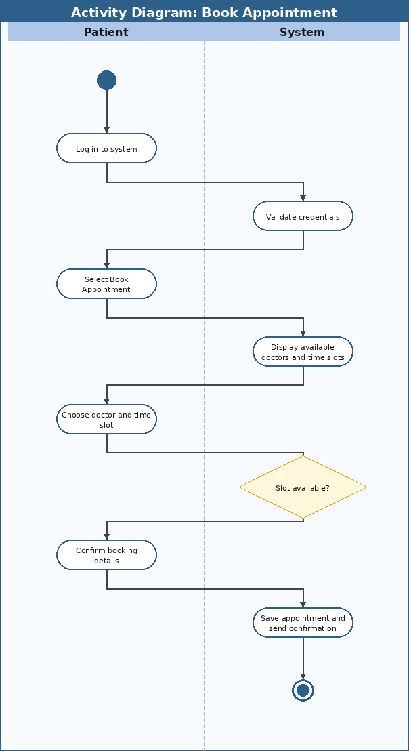

System Sequence Diagram (SSD)
The SSD below shows the messages exchanged between the Patient and the system during the booking process. Solid arrows represent input messages sent by the actor to the system, and dashed arrows show the system responding with data or confirmation. The System object represents the full automated system, which is the standard SSD notation.
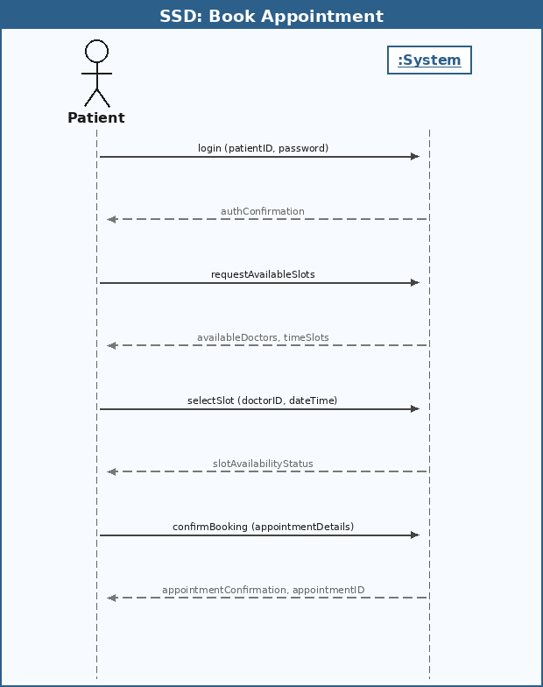

Use Case 2: Update Patient Medical Records
This use case describes how a doctor updates a patient record after a consultation. Under the old paper-based system, doctors wrote notes by hand in physical files which were then refiled on shelves. This was slow, sometimes illegible, and meant other staff could not access updated information quickly. The digital system lets doctors capture all details electronically, making records immediately available to authorised personnel.

Detailed Use Case Description
Use Case Name | Update Patient Medical Records
Scenario | Doctor updates a patient record following a consultation
Triggering Event | A doctor completes a consultation and needs to capture diagnosis, prescriptions, and follow-up instructions
Brief Description | After examining a patient, the doctor accesses the patient record and enters updated medical information. The system validates and saves the new data, timestamping the entry.
Actors | Doctor
Related Use Cases | Book Appointment, Manage Prescription, Generate Patient Summary Report
Stakeholders | Doctors, Patients, Nurses, Hospital Administration, Regulatory Bodies
Pre-conditions | Doctor must be logged in with appropriate access rights.  The patient record must already exist in the system.
Post-conditions | Patient medical record is updated with the new diagnosis, prescription, and follow-up notes.  Prescription details are stored and accessible to pharmacy staff.  The update is timestamped with the doctor's ID for audit purposes.
Flow of Activities | Actor System  1. Doctor searches for the patient record. 1.1 System retrieves and displays the full patient record.  2. Doctor enters diagnosis, prescription, and follow-up notes. 2.1 System validates that all required fields have been filled.  3. Doctor confirms and submits the update. 3.1 System saves the updated record. 3.2 System stamps the entry with date, time, and doctor ID.
Exception Conditions | 1.1 Patient record not found - system notifies the doctor and offers the option to create a new record.  2.1 Required fields are incomplete - system highlights the missing fields and blocks submission until resolved.  3.1 Save operation fails - system logs the error and notifies the doctor.

Activity Diagram
The activity diagram below maps the flow of activities when a doctor updates a patient record. The two swimlanes show the Doctor on one side and the System on the other. A decision point checks whether all required fields have been filled before accepting the submission, which prevents incomplete records from being saved.
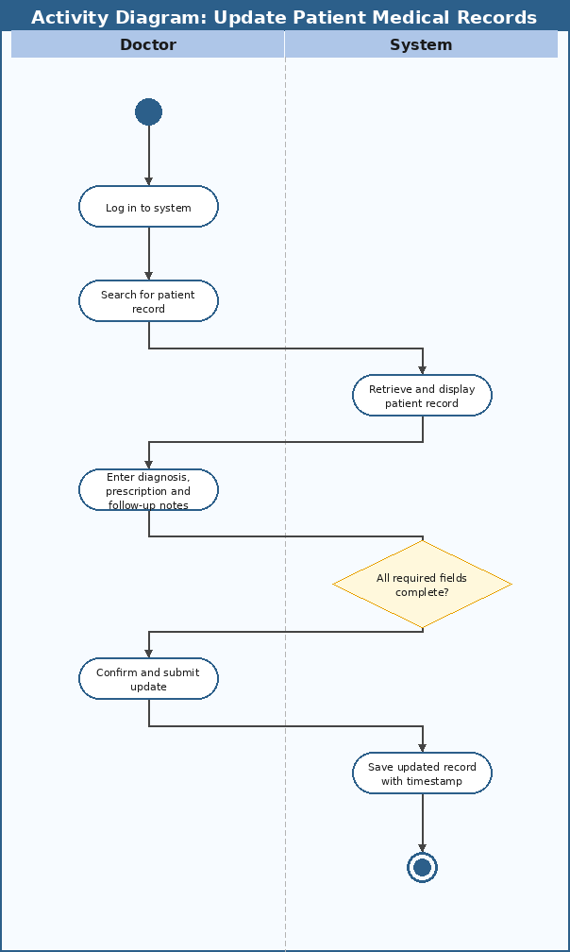

System Sequence Diagram (SSD)
The SSD below shows the interaction between the Doctor and the System during the record update process. Solid arrows indicate inputs from the doctor, and dashed arrows show the system returning data or confirmation. Parameters in parentheses indicate the data passed with each message, such as the patient ID or medical details.
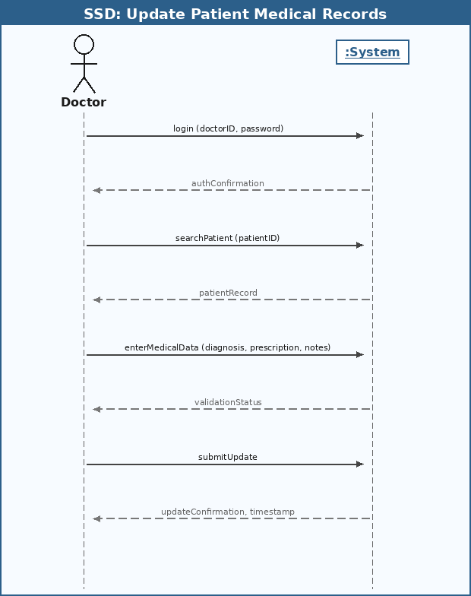

Use Case 3: Manage Prescription
This use case describes how a pharmacist or nurse accesses a patient's prescription and marks it as dispensed once the medication has been given. Under the old system, prescriptions were handwritten and physically handed over, creating a risk of loss or misread instructions. The digital system centralises prescriptions so they are accessible immediately and can be tracked from issuance to dispensing.

Detailed Use Case Description
Use Case Name | Manage Prescription
Scenario | Pharmacist or nurse accesses and processes a patient prescription through the system
Triggering Event | A patient presents at the pharmacy with a prescription that was issued by a doctor and recorded digitally
Brief Description | The pharmacist retrieves the patient's prescription from the system, verifies the details, and marks it as dispensed once the medication has been issued. The system updates the patient's medication history.
Actors | Pharmacist, Nurse
Related Use Cases | Update Patient Medical Records, Book Appointment
Stakeholders | Patients, Pharmacists, Nurses, Doctors, Hospital Administration
Pre-conditions | Prescription must have been entered into the system by a doctor.  The pharmacist or nurse must be logged in with the appropriate system access.
Post-conditions | Prescription is marked as dispensed in the system.  Patient medication history is updated to reflect the dispensed item.  The event is logged for audit and regulatory purposes.
Flow of Activities | Actor System  1. Pharmacist searches for the patient's active prescription. 1.1 System retrieves and displays the matching prescription record.  2. Pharmacist verifies the prescription details. 2.1 System confirms the prescription is valid and has not already been dispensed.  3. Pharmacist dispenses the medication and confirms the action. 3.1 System marks the prescription as dispensed. 3.2 System updates the patient's medication history.
Exception Conditions | 1.1 No prescription found - system prompts the pharmacist to verify the patient ID and try again.  2.1 Prescription has already been dispensed - system alerts the pharmacist and blocks re-dispensing.  3.1 System fails to update - an error is logged and the relevant staff are notified.

Activity Diagram
The activity diagram below maps the steps involved in managing a prescription. The Pharmacist swimlane shows the actions taken by staff, while the System swimlane shows the automated responses. The decision point checks whether the prescription is still valid and has not already been dispensed, which is an important safeguard against duplicate medication being issued.
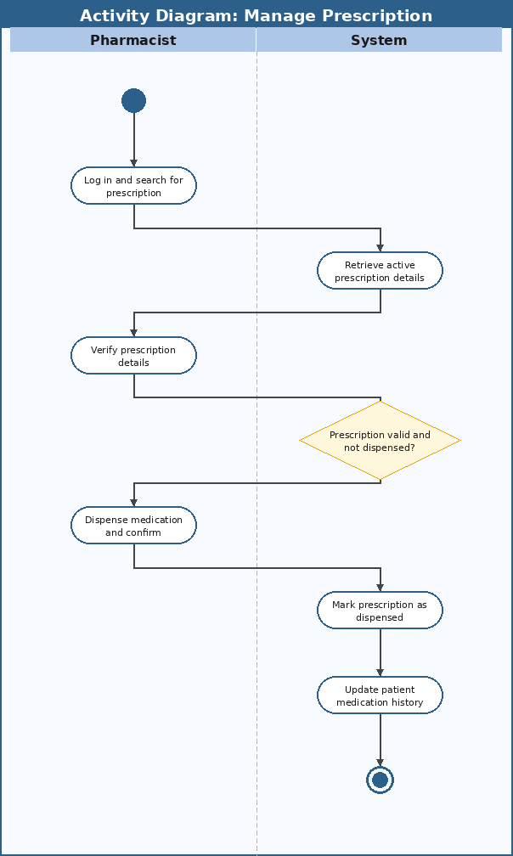

System Sequence Diagram (SSD)
The SSD below illustrates the messages exchanged between the Pharmacist and the System during prescription management. Solid arrows show actions initiated by the pharmacist, and dashed arrows show the system returning information. Data such as the prescription ID and patient ID are passed as parameters to uniquely identify the correct records.
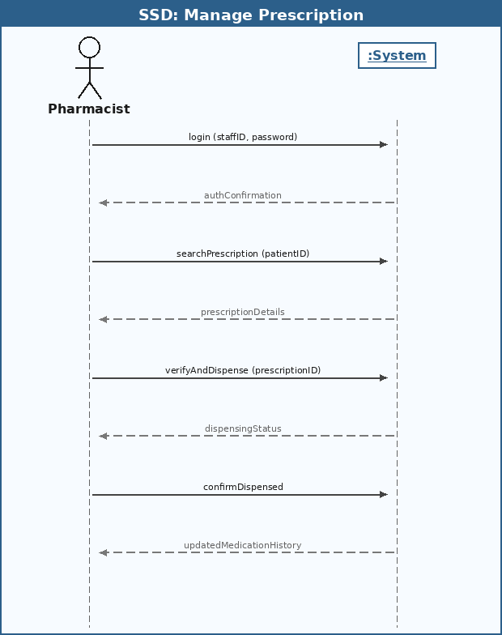

Use Case 4: Generate Patient Summary Report
This use case covers how a hospital administrator generates a summary report from the digital system. Under the manual system, producing such reports meant going through dozens of physical files by hand and compiling information manually, which was time-consuming and error-prone. The digital system automates this by querying stored records based on the administrator's parameters and producing a structured report almost instantly.

Detailed Use Case Description
Use Case Name | Generate Patient Summary Report
Scenario | Hospital administrator generates a summary report for management, oversight, or regulatory purposes
Triggering Event | An administrator requests a patient or departmental summary report through the system
Brief Description | The administrator selects report parameters such as date range and department, and the system queries the database and compiles a structured report. The report can be viewed on screen or exported as a digital file.
Actors | Hospital Administrator
Related Use Cases | Update Patient Medical Records, Book Appointment
Stakeholders | Hospital Administration, Government and Regulatory Bodies, Department Heads, Doctors
Pre-conditions | Administrator must be logged in with report generation privileges.  Relevant patient records must exist within the system for the selected parameters.
Post-conditions | Report is generated and displayed on screen for the administrator.  Report can be exported or saved as a digital file.  The report generation event is logged in the system for audit purposes.
Flow of Activities | Actor System  1. Administrator selects the report type and sets the desired parameters. 1.1 System displays available report types and filter options.  2. Administrator confirms the parameters and requests the report. 2.1 System queries the database based on the given parameters. 2.2 System compiles the data into a structured report.  3. Administrator views the report and optionally exports it. 3.1 System displays the completed report. 3.2 System provides export options such as PDF or CSV.
Exception Conditions | 2.1 No records match the selected parameters - system notifies the administrator with an appropriate message.  2.2 System encounters a data retrieval error - system displays an error and suggests the administrator retry.  3.2 Export fails - system displays an error and allows the administrator to retry the export.

Activity Diagram
The activity diagram below outlines the steps an administrator takes to generate a patient summary report. The Administrator swimlane shows how the user configures and requests the report, while the System swimlane shows the automated data retrieval and compilation. A decision diamond handles the scenario where no records match the selected parameters.
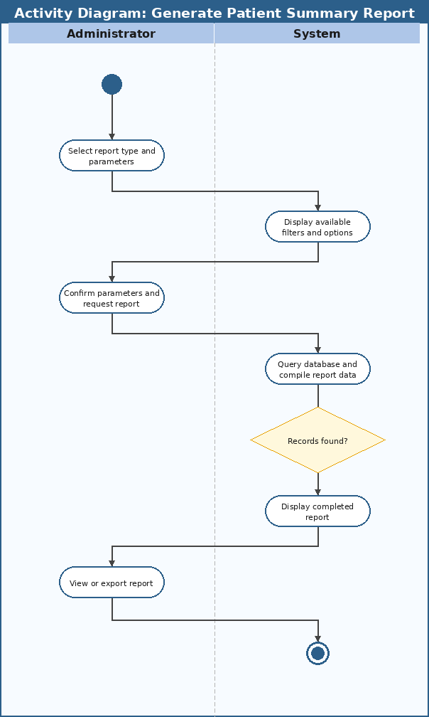

System Sequence Diagram (SSD)
The SSD below shows the message flow between the Administrator and the System during report generation. The administrator sends inputs including login credentials, report parameters, and optionally an export request. The system returns relevant data at each step and ultimately delivers the compiled report or exported file.
